Project Planning Phase
Project Planning Template (Product Backlog, Sprint Planning, Stories, Story points)

Date | 27 October 2026
Team ID | Not provided by user
Project Name | Global Olympic Sports Performance Analysis
Maximum Marks | 8 Marks

Product Backlog, Sprint Schedule, and Estimation (4 Marks)
Use the below template to create product backlog and sprint schedule
Sprint | Functional Requirement (Epic) | User Story Number | User Story / Task | Story Points | Priority | Team Members
Sprint-1 | Data audit & scope | USN-1 | As the project owner, I can inspect the four extracts and confirm their fields and roles. | 5 | High | Somesh Chelani
Sprint-1 | Data audit & scope | USN-2 | As a reviewer, I can see source limitations and the validation checks still required. | 5 | High | Somesh Chelani
Sprint-1 | Core analysis | USN-3 | As an analyst, I can compare country medals and overall rank. | 5 | High | Somesh Chelani
Sprint-1 | Core analysis | USN-4 | As an analyst, I can review total medals by Olympic year and sport category. | 5 | High | Somesh Chelani
Sprint-2 | Regional analysis | USN-5 | As a researcher, I can compare investment score, medals and regional efficiency. | 5 | High | Somesh Chelani
Sprint-2 | Regional analysis | USN-6 | As a viewer, I can inspect host-nation and regional medal patterns. | 5 | Medium | Somesh Chelani
Sprint-2 | Dashboard design | USN-7 | As a user, I can navigate two dashboards with clearly labeled charts and available filters. | 5 | High | Somesh Chelani
Sprint-2 | Dashboard design | USN-8 | As a reviewer, I can see the dashboard layout and interpretive notes. | 5 | Medium | Somesh Chelani

Project Tracker, Velocity & Burndown Chart: (4 Marks)
Sprint | Total Story Points | Duration | Sprint Start Date | Sprint End Date (Planned) | Story Points Completed (as on Planned End Date) | Sprint Release Date (Actual)
Sprint-1 | 20 | 3 working days | 28 Oct 2026 | 30 Oct 2026 | Not measured | Not released
Sprint-2 | 20 | 3 working days | 31 Oct 2026 | 02 Nov 2026 | Not measured | Not released
Sprint-3 | 20 | 3 working days | 03 Nov 2026 | 05 Nov 2026 | Not measured | Not released
Sprint-4 | 20 | 3 working days | 06 Nov 2026 | 08 Nov 2026 | Not measured | Not released
Total | 80 | 12 working days | 28 Oct 2026 | 08 Nov 2026 | Pending execution | Pending

Velocity:
Imagine we have a 10-day sprint duration, and the velocity of the team is 20 (points per sprint). Let’s calculate the team’s average velocity (AV) per iteration unit (story points per day)


Burndown Chart:
A burn down chart is a graphical representation of work left to do versus time. It is often used in agile software development methodologies such as Scrum. However, burn down charts can be applied to any project containing measurable progress over time.

https://www.visual-paradigm.com/scrum/scrum-burndown-chart/
https://www.atlassian.com/agile/tutorials/burndown-charts

Reference:
https://www.atlassian.com/agile/project-management
https://www.atlassian.com/agile/tutorials/how-to-do-scrum-with-jira-software
https://www.atlassian.com/agile/tutorials/epics
https://www.atlassian.com/agile/tutorials/sprints
https://www.atlassian.com/agile/project-management/estimation
https://www.atlassian.com/agile/tutorials/burndown-charts

Project Tracker and Planned Velocity
Total planned backlog: 80 story points across four short sprints. Planned velocity is 20 points per 3 working days, or approximately 6.7 story points per working day. This is a planning assumption, not measured historical velocity.

Planned Burndown Chart
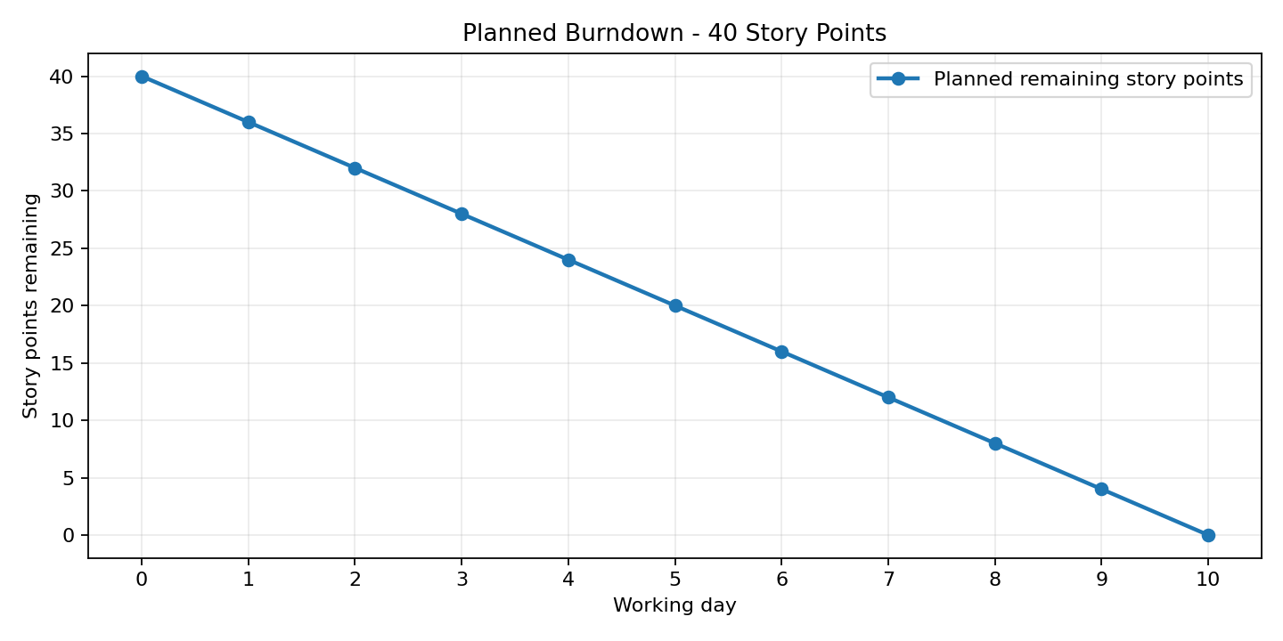
The curve is an illustrative target of remaining work (40 story points in the chart example) and is not a record of actual completed tasks. Update it from the project tracker as work is completed.

